**HackerRank Practice Assessment Details**

**How to Practice Hacker Rank?**

To know about the HackerRank assessment environment and practice the tests, follow the below steps:

  STEP 1: Login to <https://www.hackerrank.com/>

  STEP 2:  Access “For Developers” section and click on ‘Sign Up & Code’

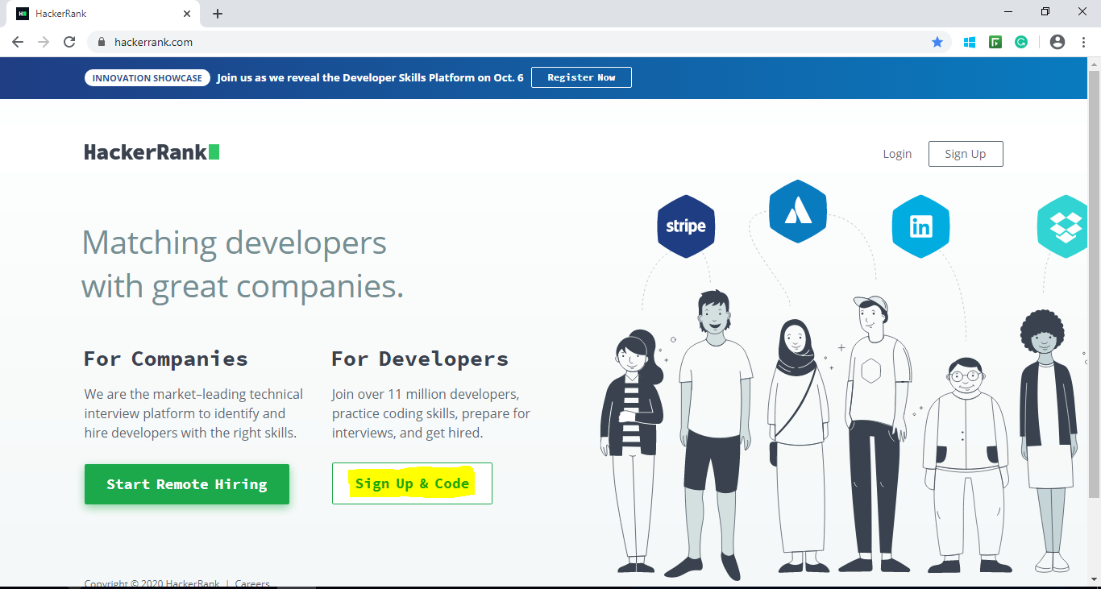

STEP 3: Provide your details and Click on ‘*Create An Account’*.

[Note: Step 3 -7 are one time activity.]

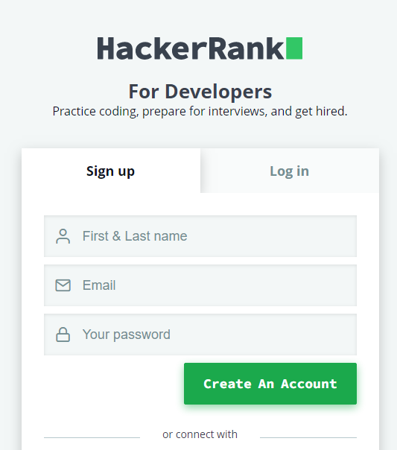

Step 4: Choose you preferred Skills.

(Ex: Java 8, Python 2/3, C#, JavaScript (Frontend and MEAN Stack associate to choose JavaScript))

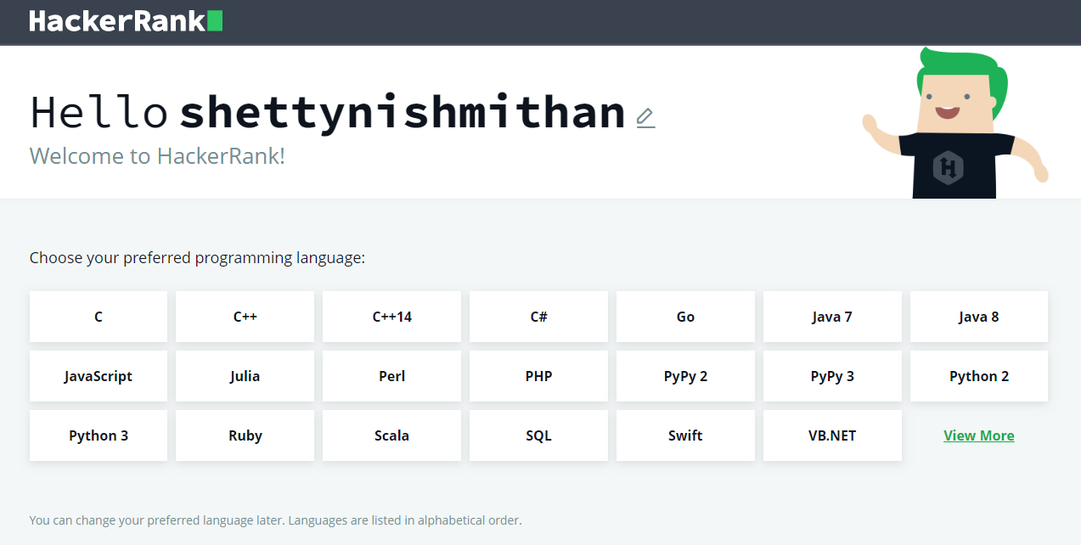

Step 5: Take your First Challenge, understand the platform and coding question. Complete the coding challenge and click on *‘****Run Code****’*.

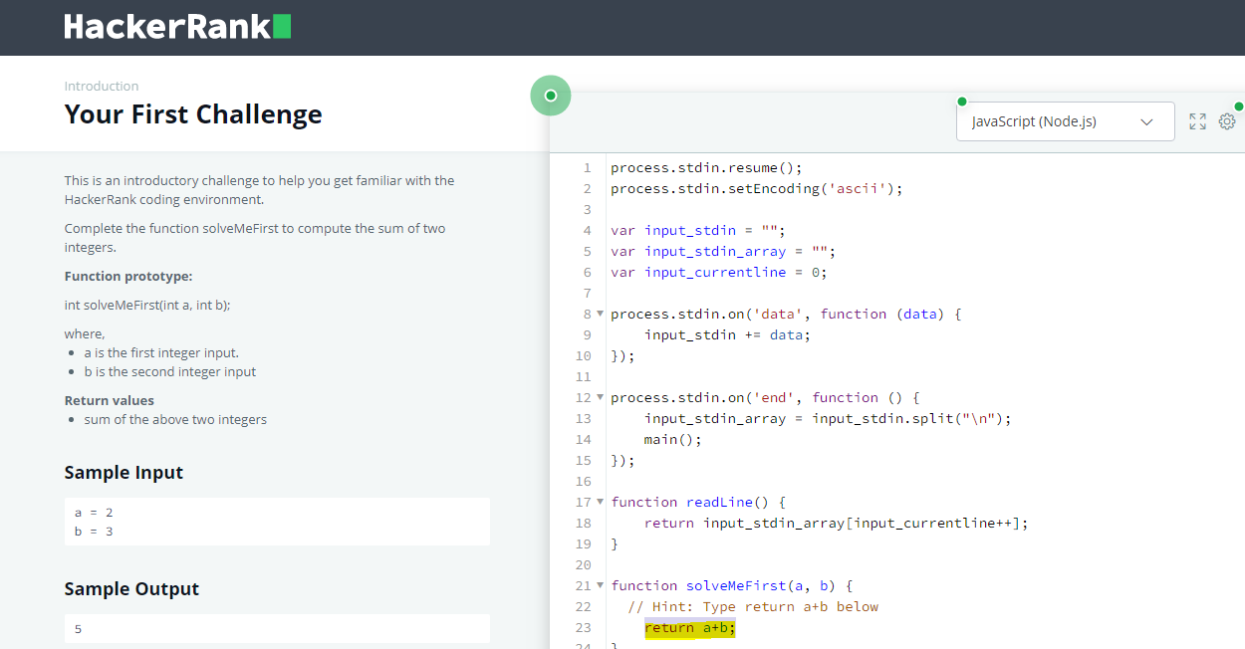

Step 6: On completion of first coding challenge, below popup would show. Click on ‘*Continue’*

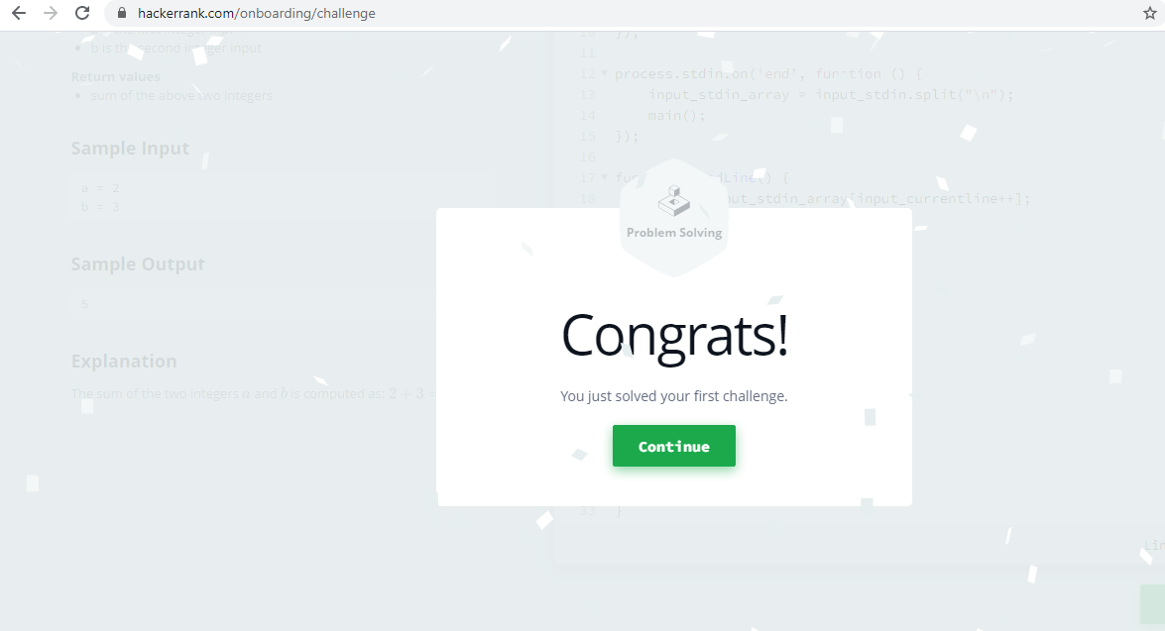

Step 7: Provide your details in the onboarding info page and click on *‘Proceed to dashboard’*

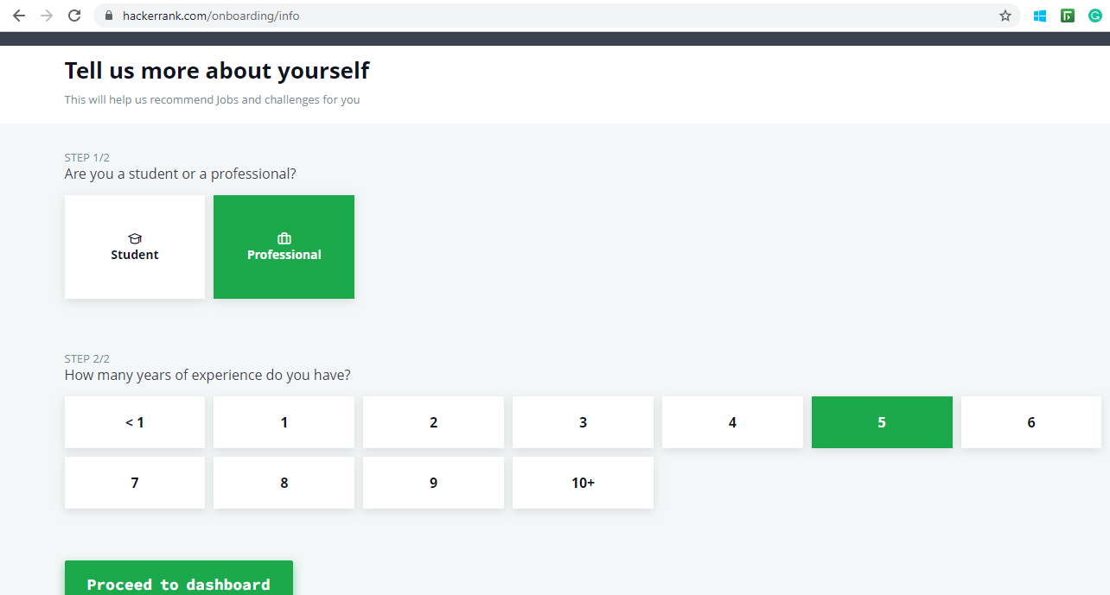

You will be navigated to HackerRank Dashboard as shown in the following screenshot.

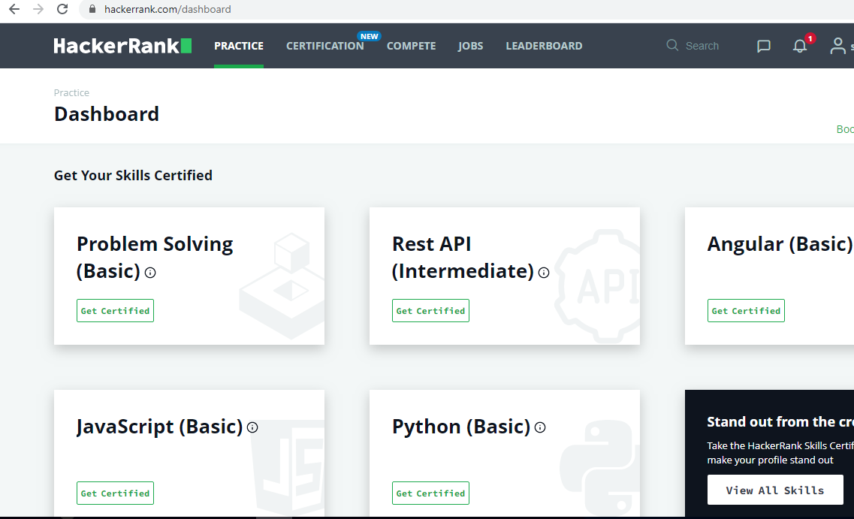

Step 8: In the HackerRank dashboard, choose one of the following skills to practice coding. (Ex.Algorithms, Data Structure etc.)

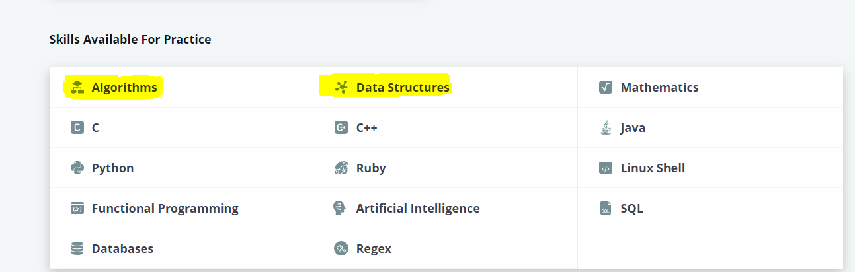

Step 9: You will be provided with number of coding challenges, click on any question to practice the test.

You will find the detailed question with sample input, output and explanations of the logic, Also there will be IDE where you would need to complete the code.

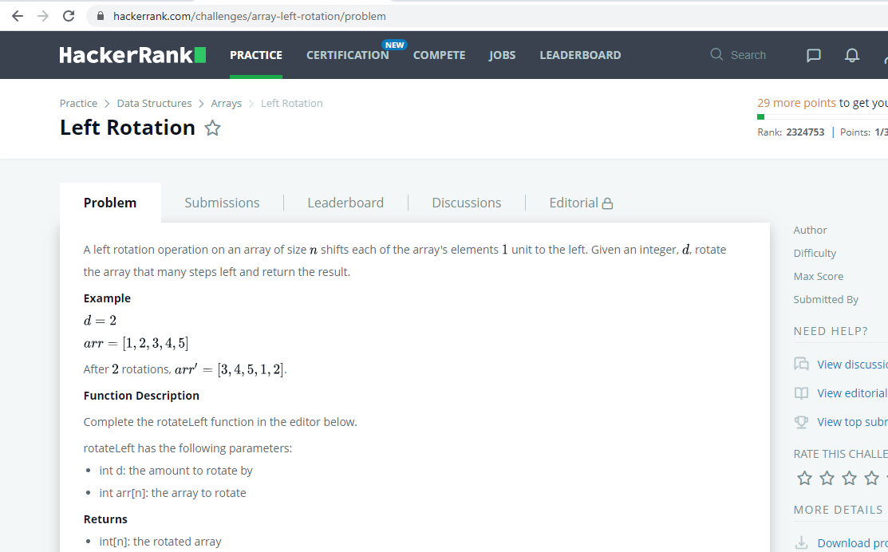

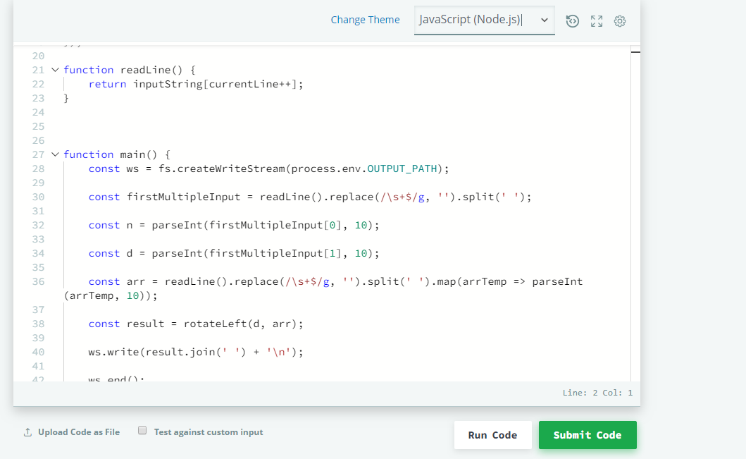

In the *Change Theme* dropdown choose following option based on the your programming language (Ex:Java )

Your test setter may include one or more test cases to validate your solution to a coding problem. These test cases are automatically executed when you run your code, and they validate different simple and corner scenarios using your solution to return the output. The execution status of each test case is displayed separately.

Based on error/failed test cases continue solving the questions until all the test cases are passed.

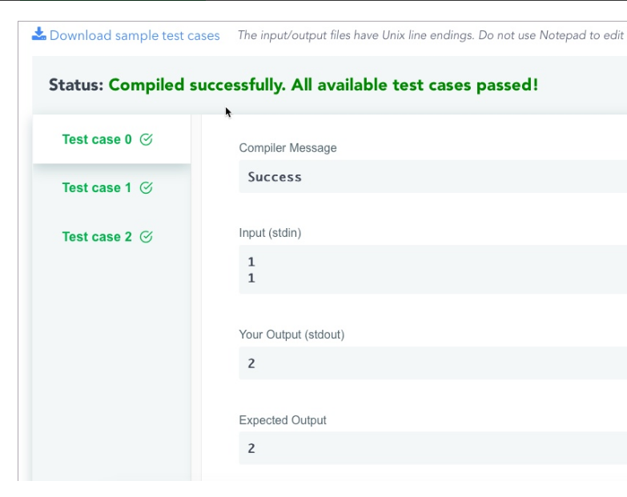

**Note:**

1. If the Autocomplete is not enabled, go to Editor Settings and Enable the Autocomplete option.

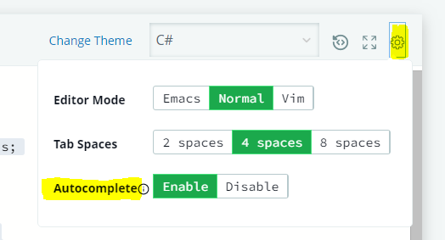

1. For few practice questions in hackerRank, **Autocomplete** option is enabled only for specific programming languages like shown in below screenshot.  You can practice using ‘Problem solving’ Get certified questions provided in hackerRank dashboard page for autocomplete enabled Java 8 questions.

In the CDE Hackerrank assessment, autocomplete option will be enabled for all assessments.



1. The score for your coding solution is calculated and assigned based on the number of test cases that execute your logic successfully to produce the exact expected output. Scoring for successfully running test cases are not same, it is based on the difficulty level of the test case.
2. If associate face any network issues, all the work that associate submitted before losing the internet connection is saved on hackerrank servers. After the internet connectivity is resumed, you can log on to the test again (if it is not passed the test completion time) and resume answering the questions. However, it is best to check your computer and internet connection before taking the Test.

**Hackerrank Samples**

Note: You can search for the challenges using the name using the search option in the Hackerrank site.

# For Java Track ONLY

|  |  |  |
| --- | --- | --- |
| **Name of the Hackerrank challenge** | **Navigation** | **Time to completed (in minutes)** |
| Java Anagrams | <https://www.hackerrank.com/challenges/java-anagrams/problem> | 30 |
| Pattern Syntax Checker | <https://www.hackerrank.com/challenges/pattern-syntax-checker/problem> | 30 |
| Java Arraylist | <https://www.hackerrank.com/challenges/java-arraylist/problem> | 30 |
| Java Exception Handling | <https://www.hackerrank.com/challenges/java-exception-handling/problem> | 30 |
| Prime Checker | <https://www.hackerrank.com/challenges/prime-checker/problem> | 40 |
| Tag Content Extractor | <https://www.hackerrank.com/challenges/tag-content-extractor/problem> | 40 |
| Java Comparator | <https://www.hackerrank.com/challenges/java-comparator/problem> | 40 |
| Java BigDecimal | <https://www.hackerrank.com/challenges/java-bigdecimal/problem> | 40 |
| Java Lambda Expressions | <https://www.hackerrank.com/challenges/java-lambda-expressions/problem> | 40 |

REST API: <https://www.hackerrank.com/skills-verification/rest_api_intermediate>

SpringBoot topics: <https://www.hackerrank.com/skills-directory/spring_boot_basic>

Additional References:

|  |  |  |
| --- | --- | --- |
| **Name of the Hackerrank challenge** | **Navigation** | **Time to completed (in minutes)** |
| Arrays – DS | <https://www.hackerrank.com/challenges/arrays-ds/problem> | 30 |
| 2D Array – DS | <https://www.hackerrank.com/challenges/2d-array/problem> | 30 |
| Left Rotation | <https://www.hackerrank.com/challenges/array-left-rotation/problem> | 30 |
| Sparse Arrays | <https://www.hackerrank.com/challenges/sparse-arrays/problem> | 30 |
| Array Manipulation | <https://www.hackerrank.com/challenges/crush/problem> | 45 |
| Mini-Max Sum | <https://www.hackerrank.com/challenges/mini-max-sum/problem> | 30 |
| Time Conversion | <https://www.hackerrank.com/challenges/time-conversion/problem> | 30 |
| Between Two Sets | <https://www.hackerrank.com/challenges/between-two-sets/problem> | 30 |
| Divisible Sum Pairs | <https://www.hackerrank.com/challenges/divisible-sum-pairs/problem> | 30 |
| Forming a Magic Square | <https://www.hackerrank.com/challenges/magic-square-forming/problem> | 45 |
| Delete duplicate-value nodes from a sorted linked list | <https://www.hackerrank.com/challenges/delete-duplicate-value-nodes-from-a-sorted-linked-list/problem> | 30 |
| Queue using Two Stacks | <https://www.hackerrank.com/challenges/queue-using-two-stacks/problem> | 35 |
| Balanced Brackets | <https://www.hackerrank.com/challenges/balanced-brackets/problem> | 35 |
| Components in a graph | <https://www.hackerrank.com/challenges/components-in-graph/problem> | 35 |
| Find the Running Median | <https://www.hackerrank.com/challenges/find-the-running-median/problem> | 45 |